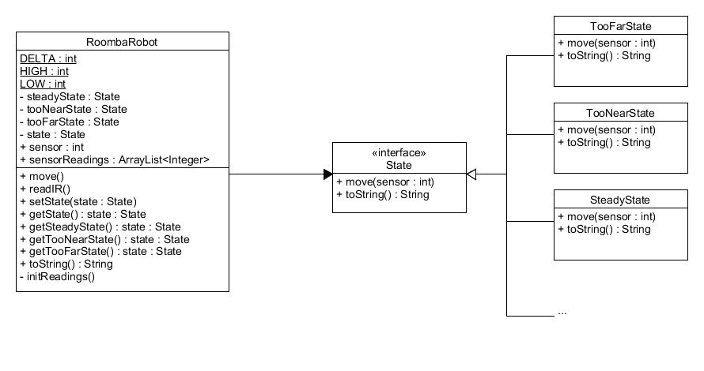1.

My design implements the state pattern. In this case, the RoombaRobot is the Context since it can have a number of internal states. The robot delegates all of the requests made on it to one of the three implemented states. The three concrete states are the TooFarState, TooNearState, and SteadyState. Each of the concrete states provides its own implementation for move and toString. Many more concrete states can be implemented quite easily. All of the movement logic for the robot is handled in the move method so there are no conditionals in the RoombaRobot class.